**Policy Management System**

**Use Case Document**

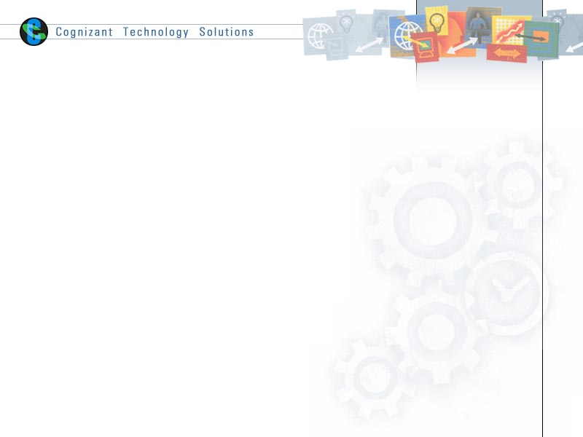

|  |  |  |  |
| --- | --- | --- | --- |
|  | Prepared By / Last Updated By | Reviewed by | Approved By |
| Name | Ayushi Dogra, Daksh Singhal, Prince Sunil Kumar, Tapas, Vinne Malik | Mr. Abhinandan | Mrs. Shilpa Mahajan |
| Role | Team Member | Mentor | Academy Head |
| Signature |  |  |  |
| Date |  |  |  |

Table of Contents

1.0 Introduction 3

1.1 Purpose & Scope of the document 3

1.2 Intended Audience 3

1.3 Use case ‘Admin Registration’ 3

1.3.1 Use case attributes 3

1.3.2 Business Rules 4

1.3.3 UI Requirements 4

1.3.4 UI Field Validations 5

1.4 Use case ‘User Registration’ 5

1.4.1 Use case attributes 5

1.4.2 Business Rules 6

1.4.3 UI Requirements 6

1.4.3 UI Field Validations 6

1.5 Use case ‘Admin Credential Authentication’ 7

1.5.1 Use case attributes 7

1.5.2 Business Rules 8

1.5.3 UI Requirements 8

1.5.4 UI Field Validations 9

1.6 Use case ‘User Credential Authentication’ 7

1.6.1 Use case attributes 7

1.6.2 Business Rules 8

1.6.3 UI Requirements 8

1.6.4 UI Field Validations 9

1.7 Use case ‘Admin Home’ 9

1.7.1 Use case attributes 9

1.7.2 Business Rules 10

1.7.3 UI Requirements 10

1.7.4 UI Field Validations 12

1.8 Use case ‘User Home’ 2

1.8.1 Use case attributes 12

1.8.2 Business Rules 13

1.8.3 UI Requirements 13

1.8.4 UI Field Validations 15

1.9 Use case ‘Policy Payment’ 15

1.9.1 Use case attributes 15

1.9.2 Business Rules 16

1.9.3 UI Requirements 16

1.9.4 UI Field Validations 17

2.0 Database Design 18

2.1 Tables Structure 18

3.0 Data Flow Diagram 19

# Introduction

## Purpose & Scope of the document

The purpose of this Use case document is to systematically capture requirements for the project and the system to be developed in terms of use cases. Functional use cases are captured in this document. It also serves as the input for the project scoping.

The scope of this document is limited to addressing the use cases from a user, quality, and non-functional perspective.

## Intended Audience

Each member of the project team

## Use case ‘Admin Registration’

### Use case attributes

**Use Case Description:**

This use case deals with the capture of admin details. The ‘admin’ here shall be the operator of the system and will be keying in the user details and policy details.

**Scope:**

* Admin registration

**Actors:**

* Admin – the operator

**Trigger:**

Click ‘Submit’ button in the ‘Admin Registration’ page

**Pre-Condition:**

Admin being able to access the login page & get redirected to the ‘Admin Registration’ page upon click of ‘New User ?’ link on the login page.

**Post Condition:**

Admin is in the registration page & submit details

**Flow of Events:**

Admin at login page 🡪 Click ‘New User ?’ link 🡪 Admin at registration page🡪 Admin is in the registration page 🡪 Admin details are submitted and added onto the database

**Primary Scenario:**

A new admin – is able to click ‘New User ?’ link and able to provide his details and get registered in the system.

### Business Rules

Business rules should be defined using the following attributes: -

* When the admin clicks on the register link, it should re-direct to registration form.
* Admin needs to fill some of the basic attributes/fields as mentioned below in requirement: User Id, First Name, Last Name, DOB, Gender, Contact Number, Address, E-Mail, Qualification, Salary per month, PAN number, Employer Type, Employer, Hint Question, Hint Answer, Password.
* Clicking ‘Register’ should validate the datatype constraints for each field
* Post-successful field level validation, save the information in the database
* Upon saving the information in the database, display the message ‘Your have successfully registered’.

### UI Requirements

Here is a prototype of the login page.

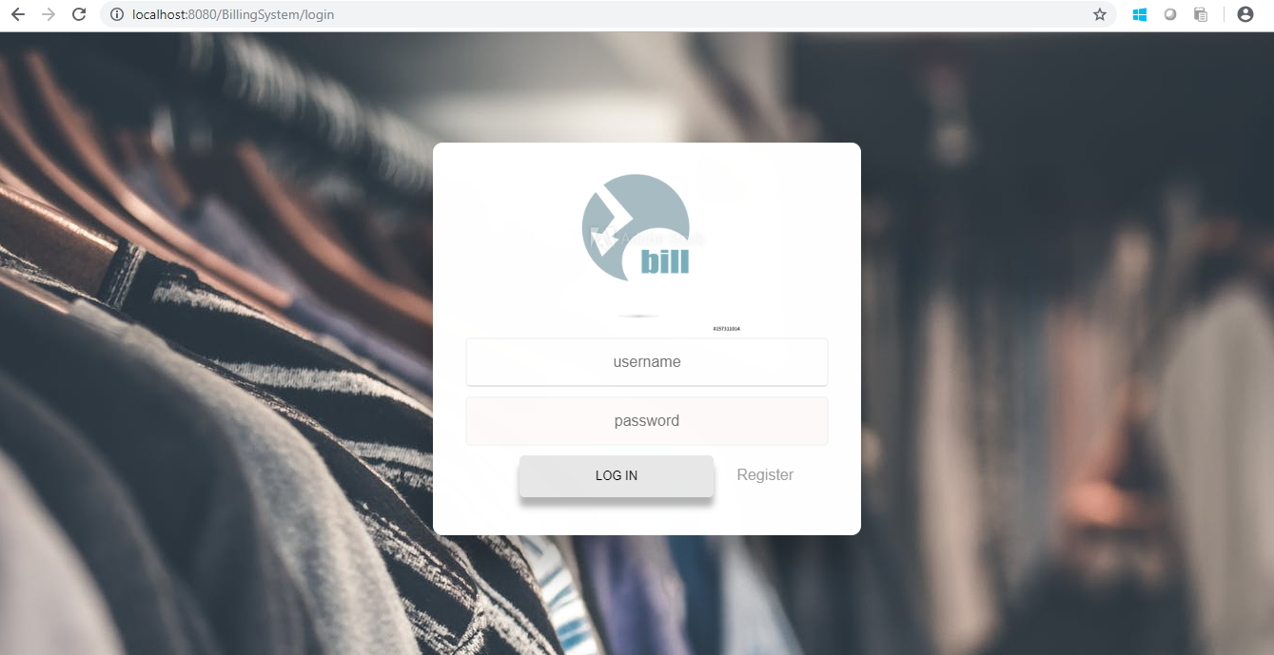

Here is a prototype on how the ‘Admin Registration’ page should look like.

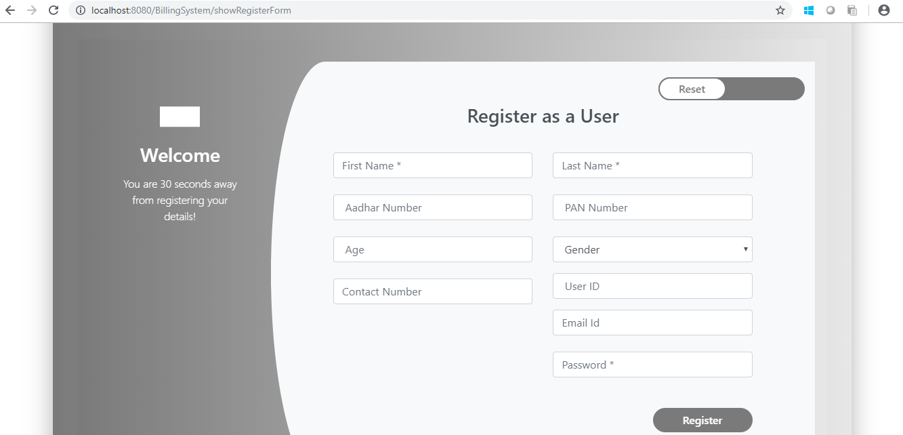

### UI Field Validations

Please refer to the below requirements for field level validations:

* All fields are mandatory.

Password should have maximum 15 alphanumeric, space & can contain special characters (ex.!,@,#,%,*,& etc.)

* The Email ID format must be checked.
* Phone Number must be of 10 digits’ length.
* First Name, Last Name should contain only alphabets.
* Gender should be chosen from the dropdown options.
* PAN, User Id should be alphanumeric maximum.

## 

## Use case ‘Admin Credential Authentication’

### Use case attributes

**Use Case Description:**

This use case deals with the authentication of the admin credentials. The ‘admin’ here shall be the operator of the system and will be keying in the user information into the system.

**Scope:**

* Admin credentials authentication

**Actors:**

Admin – the operator

**Trigger:**

Click ‘Submit’ link, after keying in ‘Username’ & ‘Password’ field.

**Pre-Condition:**

Admin being able to access the login page

**Post Condition:**

Admin is in the Admin Home Page.

**Flow of Events:**

Admin at login page 🡪 Key in ‘Username’ & ‘Password’ field 🡪 Admin credentials are validated 🡪 Admin Home page is displayed.

**Primary Scenario:**

A registered admin – is able click ‘Submit’ link, after keying in ‘Username’ & ‘Password’ field and get his credentials authenticated with the existing database entry.

**Alternative Scenario:**

A registered admin – is able click ‘Submit’ link, after keying in ‘Username’ & ‘Password’ field and unable to get his credentials authenticated. The admin is presented with relevant error messages: Invalid username or password and redirected back to the login page.

### Business Rules

Business rules should be defined using the following attributes :-

* A registered admin – is able click ‘Submit’ link, after keying in ‘Username’’ & ‘Password’ field and get his credentials authenticated with the existing database entry.

### UI Requirements

Here is a prototype of the Admin Home Page.



## Use case ‘Admin Home’

### Use case attributes

**Use Case Description:**

This use case deals with the management of policies. The ‘admin’ here shall be the operator of the system and will be keying in the policy details.

**Scope:**

* Policy Registration

**Actors:**

* Admin – the operator

**Trigger:**

Admin should get redirected to the ‘Admin Home’ page when the admin enters valid credentials.

**Pre-Condition:**

Admin should be able to get redirected to the ‘Admin Home’ page upon clicking the ‘Submit’ button on the Login page.

**Post Condition:**

Admin is in the Admin Home page & can view all the policies listed.

**Flow of Events:**

Admin at login page 🡪 Enter valid credentials 🡪 Click ‘Submit’ button 🡪 Admin in the admin home page 🡪 All the policies present in the database are displayed.

**Primary Scenario:**

Admin – is able to click ‘Submit’ button and is able to land on the admin home page and view all the policies.

### Business Rules

Business rules should be defined using the following attributes: -

* + - When the admin clicks on the submit button after entering the valid credentials, admin lands on the admin home page.
    - Admin home page contains the list of all the policies added by the admin in the database.
    - Admin home page also consists of Search Policy and Add Policy functionality.
    - All the policies listed contains two buttons.
    - One button is ‘View’ and the other button is ‘Edit’.

### UI Requirements

Here is a prototype on how the Admin Home page should look like.

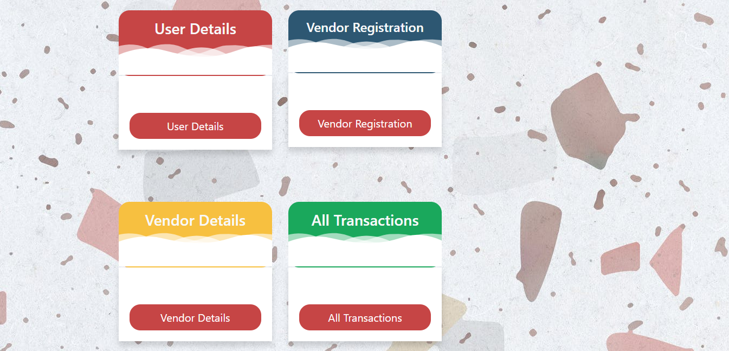

## Use case ‘Add Policy on Admin Home Page’

### Use case attributes

**Use Case Description:**

This use case deals with the ability to add new policies in the database. The ‘admin’ here shall be the operator of the system and will be keying in the policy details.

**Scope:**

* Add Policy

**Actors:**

* Admin – the operator

**Trigger:**

Click ‘Add Policy’ button in the ‘Admin Home’ page

**Pre-Condition:**

Admin being able to access the ‘Admin Home’ page by entering the valid credentials. Admin being able to reach ‘Admin Home’ page can register the details of new policies by clicking on the ‘Add Policy’ button. Once the details have been successfully entered, admin is given the option ‘Submit’ to save the entered details in the database and land back to Admin Home Page.

**Post Condition:**

Admin is successfully redirected to the Admin Home page and the new policy added is reflected on the Admin Home page.

**Flow of Events:**

Admin at Login Page🡪Enter Valid credentials 🡪 Click on ‘Submit’ button 🡪 Admin at ‘Admin Home’ page’ 🡪 Click ‘Add Policy’ button 🡪 Policy Form details are submitted and added onto the database upon clicking the ‘Submit’ button -> Admin redirected to ’Admin Home’ page.

**Primary Scenario:**

Admin is able to add new policy and record it in the database, which would then be reflected back to the user.

### Business Rules

Business rules should be defined using the following attributes: -

* When the admin clicks on the ‘View’ button of a particular policy, the admin will be redirected to ‘View Policy’ page, where all the details of that particular policy could be seen on the screen.
* When the admin clicks on the ‘Edit’ button of a particular policy, the admin will be redirected to ‘Edit Policy’ page, where all the details of that particular policy could be seen on the screen and the fields that could be edited are reflected in a light color.
* Other non-edited fields cannot be accessed.
* On clicking the submit button and post-successful field level validation, the information is again updated in the database
* A link for home page is displayed with a message ‘Success’.

### UI Requirements

Here is a prototype on how the ‘Add Policy” page should look like.

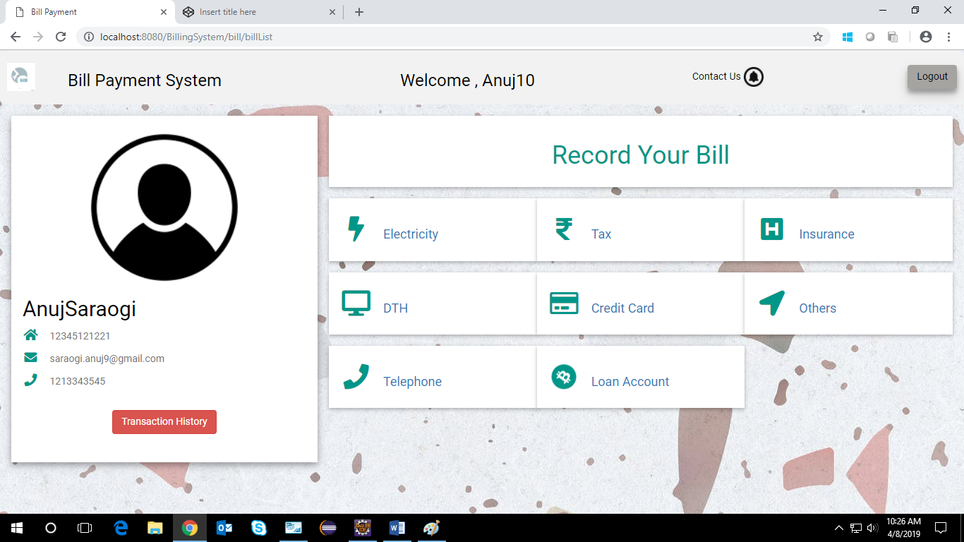

### UI Field Validations

Please refer to the below requirements for field level validations:

* All fields are mandatory.
* Duration of months should be a 2-digit number.
* Policy Id should be alphanumeric.
* Policy Name should consist of alphabets only.

## Use case ‘User Registration’

### Use case attributes

**Use Case Description:**

This use case deals with the capture of user details. The ‘user’ here shall be able to view all the policies and buy them.

**Scope:**

* User registration

**Actors:**

* User – the operator

**Trigger:**

Click ‘Submit’ button in the ‘User Registration’ page

**Pre-Condition:**

User being able to access the login page & get redirected to the ‘User Registration’ page upon click of ‘New User ?’ link on the login page.

**Post Condition:**

User is in the registration page & submit details

**Flow of Events:**

User at login page 🡪 Click ‘New User ?’ link 🡪 User at registration page🡪 Admin is in the registration page 🡪 User details are submitted and added onto the database

**Primary Scenario:**

A new User – is able to click ‘New User ?’ link and able to provide his details and get registered in the system.

### Business Rules

Business rules should be defined using the following attributes: -

* When the User clicks on the register link, it should re-direct to registration form.
* User needs to fill some of the basic attributes/fields as mentioned below in requirement: User Id, First Name, Last Name, DOB, Gender, Contact Number, Address, E-Mail, Qualification, Salary per month, PAN number, Employer Type, Employer, Hint Question, Hint Answer, Password.
* Clicking ‘Register’ should validate the datatype constraints for each field
* Post-successful field level validation, save the information in the database
* Upon saving the information in the database, display the message ‘Your have successfully registered’.

### UI Requirements

Here is a prototype of the login page.



Here is a prototype on how the ‘User Registration’ page should look like.



### UI Field Validations

Please refer to the below requirements for field level validations:

* All fields are mandatory.

Password should have maximum 15 alphanumeric, space & can contain special characters (ex.!,@,#,%,*,& etc.)

* The Email ID format must be checked.
* Phone Number must be of 10 digits’ length.
* First Name, Last Name should contain only alphabets.
* Gender should be chosen from the dropdown options.
* PAN, User Id should be alphanumeric maximum.

## Use case ‘User Credential Authentication’

### Use case attributes

**Use Case Description:**

This use case deals with the authentication of the user credentials. The ‘user’ here shall be the operator of the system and will be keying in the user information into the system.

**Scope:**

* User credentials authentication

**Actors:**

User – the operator

**Trigger:**

Click ‘Submit’ link, after keying in ‘Username’ & ‘Password’ field.

**Pre-Condition:**

User being able to access the login page

**Post Condition:**

User is in the User Home Page.

**Flow of Events:**

User at login page 🡪 Key in ‘Username’ & ‘Password’ field 🡪 User credentials are validated 🡪 User Home page is displayed.

**Primary Scenario:**

A registered user – is able click ‘Submit’ link, after keying in ‘Username’ & ‘Password’ field and get his credentials authenticated with the existing database entry.

**Alternative Scenario:**

A registered user – is able click ‘Submit’ link, after keying in ‘Username’ & ‘Password’ field and unable to get his credentials authenticated. The user is presented with relevant error messages: Invalid username or password and is redirected back to the login page.

### Business Rules

Business rules should be defined using the following attributes :-

* A registered user – is able click ‘Submit’ link, after keying in ‘Username’’ & ‘Password’ field and get his credentials authenticated with the existing database entry.

### UI Requirements

Here is a prototype on how the Policy Management System Login page should look like.



## Use case ‘User Home’

### Use case attributes

**Use Case Description:**

This use case deals with the ability of the system to display all the policies and let user purchase them. The ‘user’ here shall be the operator of the system and will be keying in the payment details.

**Scope:**

* User Home

**Actors:**

* User – the operator

**Trigger:**

User should get redirected to the ‘User Home’ page when the user enters valid credentials.

**Pre-Condition:**

User should be able to get redirected to the ‘User Home’ page upon clicking the ‘Submit’ button on the Login page.

**Post Condition:**

User is in the User Home page & can view all the policies.

**Flow of Events:**

User at login page 🡪 Enter valid credentials 🡪 Click ‘Submit’ button 🡪 User in the user home page 🡪 All the policies present in the database are displayed.

**Primary Scenario:**

User – is able to click ‘Submit’ button and is able to land on the user home page and view all the policies and buy them.

### Business Rules

Business rules should be defined using the following attributes: -

* + - When the user clicks on the submit button after entering the valid credentials, user lands on the user home page.
    - User home page contains the list of all the policies added by the admin in the database.
    - User home page also consists of Search Policy and Buy Policy functionality.
    - All the policies listed contains two buttons.
    - One button is ‘View’ and the other button is ‘Buy’.
    - When the user clicks on the ‘View’ button of a particular policy, the user will be redirected to ‘View Policy’ page, where all the details of that particular policy could be seen on the screen

### UI Requirements

Here is a prototype on how the User Home page should look like.

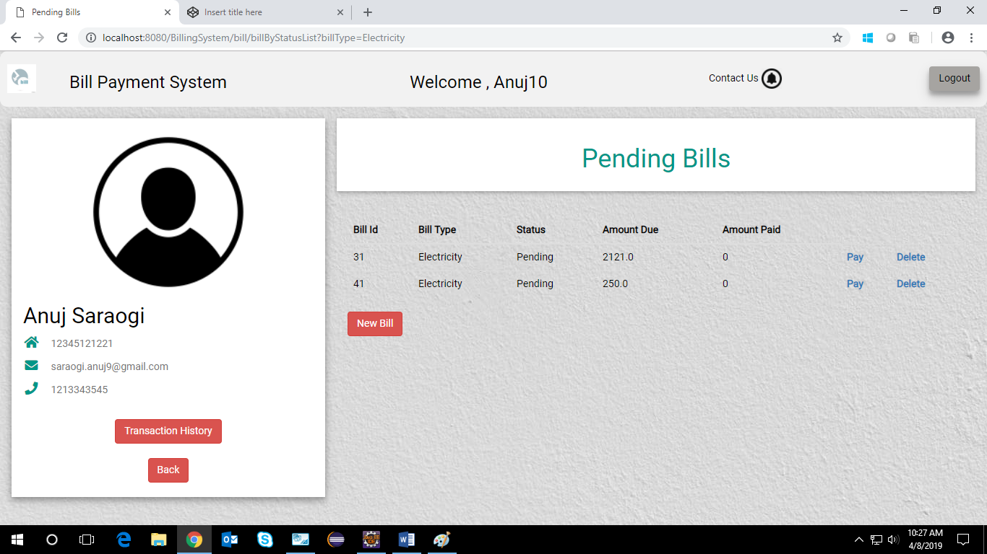

## Use case ‘Policy Payment’

### Use case attributes

**Use Case Description:**

This use case deals with the ability of the user to buy the policy and pay for it via different payment methods. The ‘user’ here shall be the operator of the system and will be keying in the policy payment details.

**Scope:**

* Policy Payment

**Actors:**

* User – the operator

**Trigger:**

Click ‘Buy’ button on the ‘User Home’ Page for the policy user wants to buy.

**Pre-Condition:**

User being able to access the ‘My Policy’ button and check the payment status by clicking on the ‘Payment’ button. If the pop up occurs with the message ‘You have already paid for the policy’ then this shows the user had bought the policy again. Else the user will be redirected to the payment page. As soon as user clicks on ‘Buy’ in ‘User Home’ page, the entry will be removed from the page and will be only visible in ‘My Policy’ page.

**Post Condition:**

On clicking the ‘Payment’ button user is redirected to the ‘Payment’ page which consists of multiple payment methods like Credit/Debit Card, Net Banking, UPI.

**Flow of Events:**

User at login page 🡪 Enter valid credentials 🡪 Click ‘Submit’ 🡪 User at User Home page 🡪 Click ‘Buy’ button 🡪 User at Payment Page which displays different payment options🡪 User selects one of the payment options and accordingly buys the policies.

**Primary Scenario:**

User being able to access the ‘My Policy’ button and check the payment status by clicking on the ‘Payment’ button. If the pop up occurs with the message ‘You have already paid for the policy’ then this shows the user had bought the policy again. Else the user will be redirected to the payment page.

### Business Rules

Business rules should be defined using the following attributes: -

* When the user clicks on the ‘Buy’ button, it should re-direct to the ‘Payment’ page.
* Where user can choose the payment method and pay bill.
* Post-successful payment, the corresponding policy status is changed from pending to paid.
* Thereafter we redirect User to ’User Home’ page.

### UI Requirements

Here is a prototype of Policy Payment Page with utton -

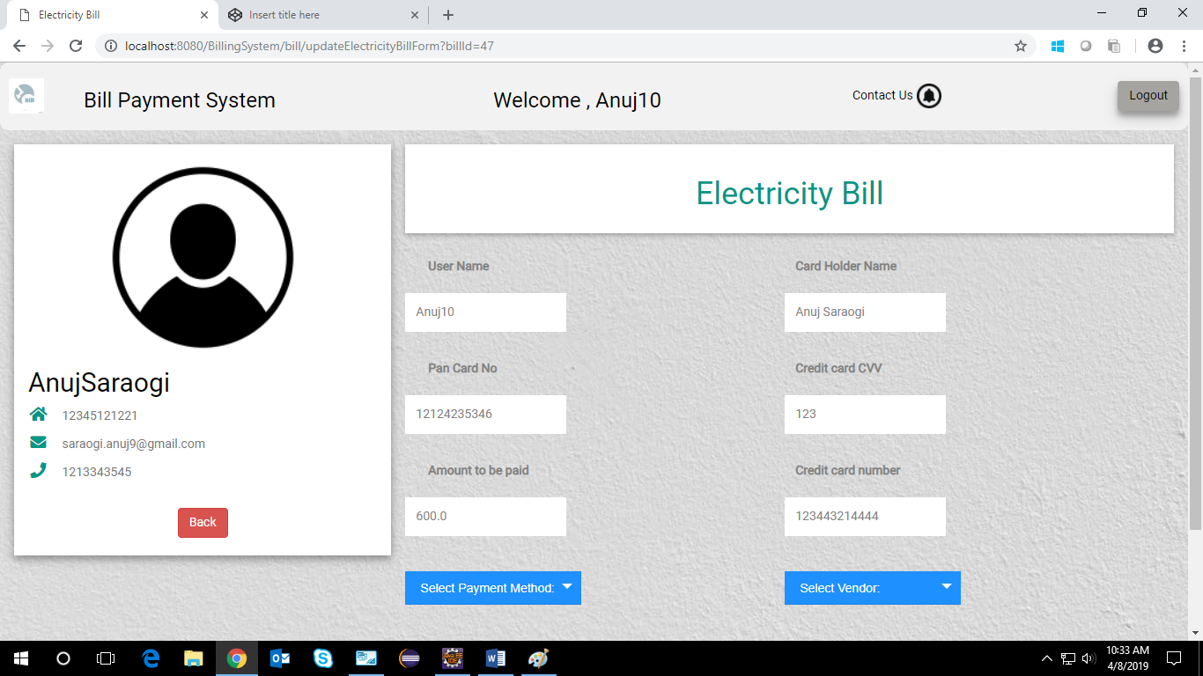

Here is a prototype of Bill Payment Page with Pay Bill button if a user select a new bill to be payed –

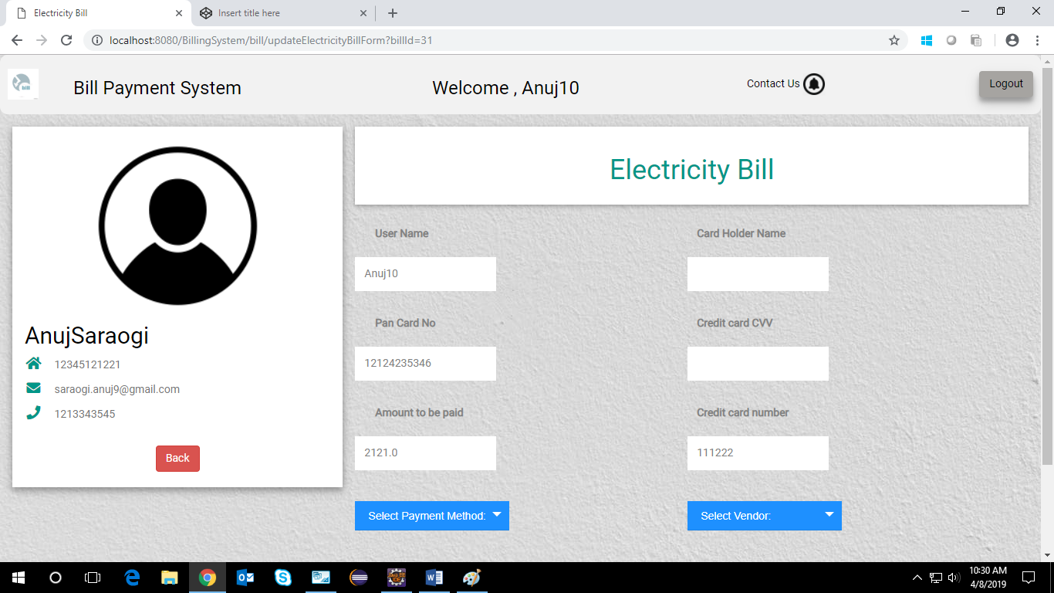

# Database Design

## Tables Structure

**User/Admin Registration:**

|  |  |  |  |
| --- | --- | --- | --- |
| **Column Name** | **Data Type** | **Length** | **Mandatory** |
| firstName | alphabetic | 50 | Yes |
| lastName | alphabetic | 50 | Yes |
| DOB | DD/MM/YYYY | 10 | Yes |
| Gender | NA |  |  |
| Contact number | numeric | 10 | Yes |
| Address | alphanumeric | 60 | Yes |
| Email-id | alphanumeric | 15 | Yes |
| Qualification | alphanumeric | 10 | Yes |
| Salary per month | numeric | 10 | Yes |
| PAN no. | alphanumeric | 10 | Yes |
| Employer Type | alphanumeric | 10 | No |
| Emplopyer | alphanumeric | 10 | No |
| Hint Question | alphanumeric | 50 | Yes |
| Hint Answer | alphanumeric | 50 | Yes |
| Password | alphanumeric | 15 | Yes |

**Policy Details:**

|  |  |  |  |
| --- | --- | --- | --- |
| **Column Name** | **Data Type** | **Length** | **Nulls** |
| Policy Id | alphanumeric | 50 | Yes |
| Policy Name | alphanumeric | 50 | Yes |
| Policy Type | alphanumeric | 10 | Yes |
| Duration of Years | Numeric | 2 | Yes |
| Company | Alphanumeric | 50 |  |
| Initial Deposit | Numeric | 10 | Yes |
| User Type | Alphanumeric | 10 | Yes |
| Term Amount | numeric | 15 | Yes |
| Interest | Numeric | 2 | Yes |

# Data Flow Diagram

